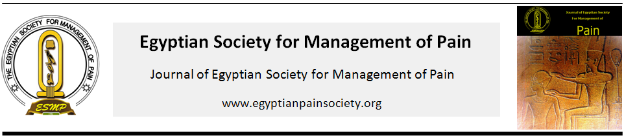

EVALUATION OF CELIAC PLEXUS BLOCK BY COMPUTED TOMOGRAPHY GUIDED TRANS-AORTIC APPROACH FOLLOWING FAILURE OF CLASSIC APPROACH

Ekramy M. Abdelghafar, MD, Dina N. Abbas, MD.
Department of Anesthesiology, ICU and Algology, National Cancer Institute, Cairo University, Egypt.

ABSTRACT

Corresponding author
Dina Nabeel Abbas, Assistant Professor, Department of Anesthesiology, ICU and Algology, National Cancer Institute, Cairo University, Egypt.

E- mail

dina_n.abbas@yahoo.com

Several techniques for celiac plexus block (CPB) have been described after frequent difficulties in classic approach. In this study we used the CT guidance for CPB trans-aortic approach with a road map for site of needle entry tailored to each patient after failure of classic approach in upper abdominal cancer pain.
Sixty patient in whom the classic approach had technical problems or ineffective previous classic technique was included in the study. A percutaneous single needle CT guided transaortic celiac plexus block was done at L₁ vertebra level preceded by an individualized patient’s CT image simulated block in which geometric parameters for the distance, angle and depth of the blocking needle were measured. Duration of the block, visual analogue score (VAS) for pain, daily morphine consumption and adverse effects were recorded.
Five patients were excluded from the study after geometric parameters were taken; because we couldn't pass the needle through this trajectory without injuring the left kidney. The mean VAS and daily morphine consumption were significantly decreased after the block. A part from hypotension and diarrhea there were no major adverse effects.
The CT guided single needle trans-aortic CPB block for intractable upper abdominal cancer pain is proved to be safe and reliable procedure in difficult and failed cases of classic approach.

Keywords: celiac plexus block; CT guided; upper abdominal cancer pain; geometric parameters.

Accepted for publication: April 10, 2014

INTRODUCTION

The celiac plexus is considered the largest visceral plexus in the body and it is located in the retro-peritoneal space over the anterolateral surface of the abdominal aorta at the origin of the superior mesenteric artery and celiac axis^{1,2}. It is formed by the celiac, superior mesteric and aorticorenal ganglia, they form a dense network of interconnecting nerve fibers³. It is mainly composed of the preganlionic sympathetic efferent fibres from the greater splanchnic (T₅–T₉), lesser splanchnic (T₁₀,₁₁) and least splanchinic (T₁₂), the posterior trunk of the vagus nerve share in the formation of the plexus by preganglionic parasympathetic fibers. In addition, the visceral afferent fibers that carry nociceptive impulses from the upper abdominal viscera (the distal esophagus to the transverse colon) travel through the celiac plexus beside the splanchnic nerves before terminating in the spinal cord^{1,3,4}. Therefore celiac plexus neurolysis is an effective method to control pain arising from these organs^{5,6}. Celiac ganglion neurolysis have been performed for many years using bony and cutaneous landmarks subsequent to the original description of kappis in 1919⁷. The common practice using fluoroscopy for needle placement in posterior approaches to celiac plexus block is that the needle is introduced at a certain distance from midline with the needle tip directed to L₁ vertebral body and ' walked off ' the bone to reach the target area on either side⁸. However, this approach for CPB sometimes cannot be used in patients whose anatomical relationships of retroperitoneal organs are distorted by tumor growth or by a previously performed surgery. Also, in transcrural celiac block with this technique the needle may injure vital organ resulting in complications⁹. To avoid such complications, we previously reported a modified, fluoroscopy-guided trans-aortic CPB without major complication¹⁰. Computed tomography (CT) technology was used by many authors in the last years, they reported that it allows 3 dimensions image, improve results and decrease complication¹¹. it was mentioned that CT represents at present the best imaging guidance technique in numerous intervention procedures¹². Owing to high spatial resolution and the good tissue contrast .it is possible to place precisely and safely the needle on target and lytic agents can be delivered with high reliability. This results in significant reduced morbidity (less than 2.5% out of 756 interventions and improved effectiveness of the various intervention procedures¹³.
In this study we used the CT guidance in the trans-aortic celiac CPB with a road map for site of needle entry tailored to each patient after failure of classic approach in upper abdominal cancer pain.

PATIENTS AND METHODS

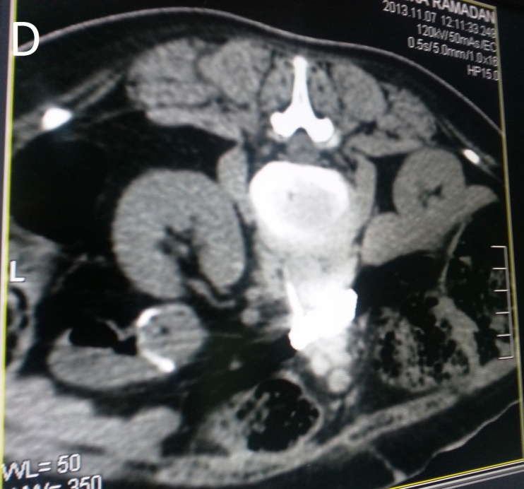
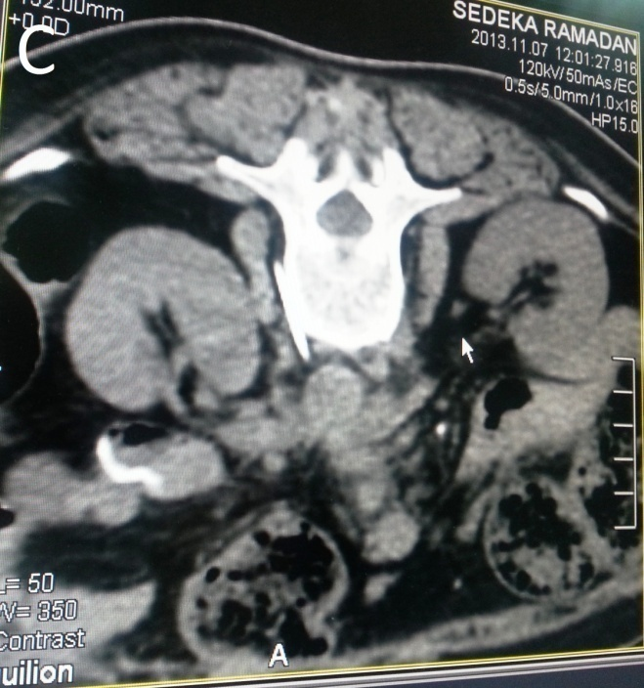
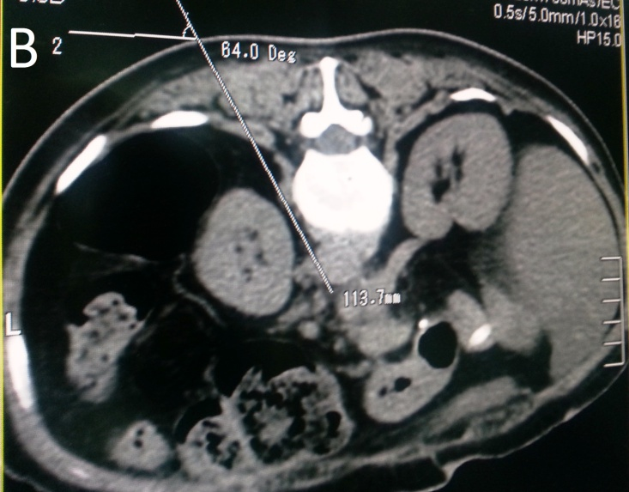
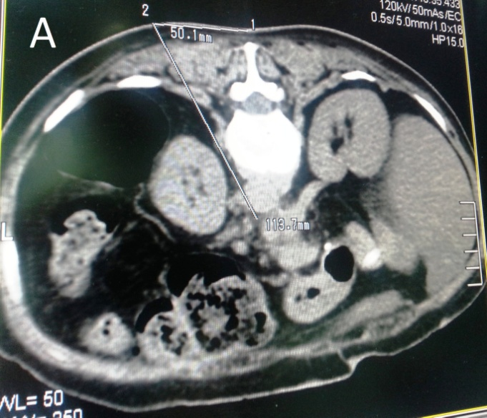
After approval of local ethics committee and obtaining informed written consent, 60 patients with refractory intra-abdominal cancer pain were recruited from the National Cancer Institute pain clinic between January 2011 and November 2013. Patients whom the classic approach had technical problems (patient can not lay prone, or due to organomegaly) or ineffective previous classic technique were included in the study. Through and detailed pain history was taken, physical examination and complete neurological examination was done for all patients. Patients with coagulopathy, local infection at area of needle insertion, mental disorders, abdominal aortic aneurysm or intestinal obstruction were excluded from the study. Visual analogue Score (VAS) for pain and total dose of morphine were assessed before the procedure. Patients were informed by steps of the CT guided celiac plexus block procedure and its possible complications. Oxygen saturation monitor, heart rate and non invasive blood pressure monitor were applied before and during the procedure. An intravenous catheter (18 G) was inserted 500 cc lactated Ringer solution was infused before the procedure, also 1 gm third generation cephalosporin was injected. Midazolam 0.03 mg/kg was given intravenously for sedation. Usually the block were performed in prone position but if patients couldn't' tolerate lying prone they were placed in the lateral position. We obtained an additional CT image to map the pathway of the blocking needle with the patient in a position that will be taken for the subsequent procedure. CT scans of thin sections (5-mm thick at 5-mm integrals) were obtained across the lower border of T₁₂ to the upper border of L₂. We selected L₁ level where the aorta is located left anterior to the L₁ body. The following measurements were taken: First, a line traversed between the anterior margin of vertebral body and the vital organs without contact, passing through the aorta just anterior to its anterior Wall (representing the endpoint of the needle advancement) (fig. 1-A) second, a line from the midline at spinous process medially to left lateral at needle entry point (distance from the midline to the needle entry point across the skin) (fig. 1-A) Third, the angles between the needle trajectory lines and the skin surface were measured in degree (fig. 1-B) with a protractor¹⁴. After measuring the three parameters Simulating needle placements were then implemented on each image then a single needle (chiba 15 cm, 20G) was passed through the posterior and anterior wall of the aorta by way of a left posterior paravertebral approach (fig. 1-C). After the needle had traversed the anterior aortic wall and was in the pre-aortic space, aspiration was performed before injection to prevent systemic distribution of the neurolytic agent¹⁵. Once the needle position was confirmed in the pre-aortic space, 3–4 ml of nonionic dye is injected to monitor its distribution (fig. 1-D) then 40 ml (50% alcohol) was injected. Patients were observed closely in the recovery room for an hour after the procedure and referred to the ward to be noticed for adverse effects and pain relief. Geomatric parameters (Needle depth, angle of needle introduction, and the distance between the need entry point and the midline) were recorded; also the duration of the block was recorded. The analgesic efficacy of the block was evaluated by assessing the total morphine consumption and the VAS before the block, 1, 2, 4, and 8 weeks after the block. Gradual withdrawal of opioid drugs was tried according to the patient's needs. The technique was considered successful if there is reduction in the dose of morphine or there was satisfactory pain relief (VAS > 3). Adverse effects related to the procedure such as failure to introduce the needle and complete the technique, failure to relived pain, needle related pain, retroperitoneal hematoma, preumothorax diarrhea, organ injury, postural hypotension and neural injury were recorded.
Figure 1. CT images simulated block in celiac plexus block posterior approach.
Statistical analysis
Statistical analysis was carried out using stat view for windows software package version 4.57 (APACUS concepts, Berkely, CA). Data were represented as means±SD, percentage, and number. Statistical analysis was performed using wilcoxon signed-rank test for VAS score changed from the baseline. Morphine consumption was tested using paired t-test, statistical significance was accepted for p value less than 0.05.

RESULTS

Demographic data and duration of the block are shown in table 1.

Table 1. Demographic data and duration of the block.
Variable | Value  (n=60)
Age (year) | 60±9
Gender (M/F) | 38/22
Weight (kg) | 63±7
Height (cm) | 165±8
Data are presented as mean±SD and number.

Clinical data are shown in table 2. Duration of the block was 50±6.8 minutes. Five patients were excluded from the study due to narrow window as it was impossible to introduce the needle without penetrating the left kidney (table 3). The morphine consumption was decreased significantly (p > 0.05) one week after the block however, two, four, and eight weeks after the block there was significant decrease in morphine consumption compared to both preblock and one week after the block, (table 4). The success rate was in 92.7% after 2 hours, one week, and 4 weeks and reduced to 90% after 6 weeks, and to 88% after 8 weeks. The mean VAS decreased significantly (P > 0.05) 2 hours after injection compared with the pre-block period and was sustained through the study periods (table 5). There was no major adverse effects and complications (table 6).

Table 2. Clinical data.
Variable | Value  (n=60)
Cancer diagnosis  Cancer pancreas  Hepatocellular carcinoma  Cancer stomach  Biliary carcinoma  Lower third oesophagus | 21  18  9  5  7
Causes of failure of classic approach  Inaccessible classic approach  Failure of pain relief  patient can't lay prone | 20  12  28
Data are presented as number.

Table 3. Geometric measurements.
Variable | Value  (n=60)
Distance from midline(cm) | 4.2±1.3
Angle of entry (degree) | 62±7.2°
Depth of needle(cm) | 12±2.4
Data are presented as mean±SD.

Table 4. Morphine consumption.
Variable | Value  (n=55)
Pre-block  Post-block (1 week)  Post-block (2 weeks)  Post-block (4 weeks)  Post-block (8 weeks) | 160±12  75±13*  54.6±12*†  58.3±14*†  52.7±11*†
Data are presented as mean±SD.
*= significant compared to preblock.
†= significant compared to 1 week.

Table 5. Visual analogue score.
Variable | Value  (n=55)
Pre- block | 74±6
Post-block (2 hours) | 25±5*
Post-block (1 week) | 28±2*
Post-block( 2 weeks) | 24±9*
Post-block (4weeks) | 29±3*
Post-block (8 weeks) | 25±6*
Data are presented as mean±SD.
*= significant compared to preblock.

Table 6. Adverse effects.
Variable | Value  (n=55)
Failure to relieve Pain | 4 (7.3%)
Needle related pain | 6 (10.97%)
Retroperitoneal hematoma | 0(0%)
Pneumothorax | 0(0%)
Diarrhea | 8 (14.5%)
Organ injury | 0(0%)
Postural hypotension | 15 (27.2%)
Neural injury | 0(0%)
Data are presented as number(%).

DISCUSSION

Pain management of advanced upper abdominal malignancy is of paramount importance. The ineffectiveness and side effects of narcotic drugs has led many pain therapists to recommend chemical neurolysis of celiac plexus for pain control¹⁶⁻¹⁹. Chemical neurolysis of celiac plexus is a highly effective technique that blocks transmission and produce significant or complete control of deep visceral pain¹⁶⁻¹⁹.
To perform neurolysis safely and get good results, pain therapist should have a perfect understanding of the anatomical relationship of the celiac plexus and its surrounding structures, which achieve the safest possible technique¹⁴. The usual, unguided technique uses the midline, twelfth rib, and needle contact with the vertebral body as landmarks⁷. An unguided technique cannot consider the anatomical variations that may be present^{8,9}. Currently all celiac plexus block are achieved under imaging guidance²⁰. The best imaging modality for the block remains controversial. For posterior approaches, the fluoroscopy and CT imaging are the most commonly used methods²¹. Fluoroscopy although it dynamically monitors needle advancement and dye-containing injectate spreading with continuous imaging, it doesn't show anatomic details²¹. CT imaging provides anatomic details but it is more time consuming and with more radiation exposure²², in a study done by (Jeong Min Lee 2000) on 28 patient (having upper abdominal malignanay) using CT technology, by three different techniques, anterior CT guided, posterior bilateral transcrural, and one needle trans-aortic CT guided techniques reported that every technique has its merits and demerits, compared to the others. He postulated that Two–needle transcrural approach permitted the spread of injected material anterior to the aorta, where the celiac plexus is most concentrated, and avoiding the risk of somatic nerve root injury. Single needle transa-ortic technique, despite the potentiality of aortic trauma and subsequent occult retroperitoneal hemorrhage, may be safer than the classic two-needle posterior approach. However both techniques of posterior approach are not suitable for terminally ill patients who are unable to tolerate the prone position and those who required meticulous monitoring and good ventilation. His results showed that 21(78%) patients had some pain relief but little or significant benefit was noted in seven patients²³. Despite the controversy about the imaging guidance modality, the method to place the blocking needle has not changed much from its original technique²⁴. The methodological description in literature has a character of, one set of needle introduction parameters fits all patients whatever the situation may be whereby: the needles are introduced on each side with an equal distance from the midline (7 Cm off the midline)¹⁸. The needles are introduced on each side with angle from the skin surface (45 or larger), the needle tips are to slide off the body of the vertabra equally on each side²⁵⁻²⁶. In our study using the CT guidance, we performed a block simulated on every individual patient’s CT image to obtain relevant measurements before subsequent block. The patient is positioned on the CT table in a position allowing for the shortest and least complicated route to the celiac plexus. Appropriate patient positioning is vital for a successful procedure because not only does it determine a safe percutaneous path, it also ensures patient comfort, which minimizes motion. We demonstrated a great difference from this classic description in all aspects, where the needle trajectory required a much closer distance to the midline (4.2±1.3 Cm) with steep angle (62±7.2). This observation is also different from the classic trans-aortic teaching. In which, left-sided needle is to be inserted 7–8 cm lateral to the midline and advanced until the pulsation emanating from the aorta and transmitted to the advancing needle is noted²⁶, then pass through the aorta till cessation of blood flow²⁷. The aortic pulsation felt through an advancing needle a traumatically is frequently difficult. If the needle is placed through the ‘window’ which is tailored to each patient, the intentional searching for the aortic pulsation with an advancing needle becomes unnecessary. It is to be considered that 5(8.3%) patients were excluded from the study; because of failure to introduce the needle bypassing the bone without injuring the left kidney had tight proximity of various vital organs to the vertebra. All posterior approaches to CPB would be traumatic and unsafe. In these cases, we would recommend the use of ultrasound-guided gastroscopic CPB anteriorly. Thanks to preview of their CT images before CPB that could discover this condition and thus avoid traumatic attempts. In a study done by (I.Y. yang et al 2011) where they studied Transcrural coeliac plexus block simulated on 200 computed tomography .The characteristics of their 200 patients whose CT images of the upper abdomen were reviewed, 107 patients with normal upper abdomen, 93 had pathologies including, 21 with pancreatic cancer, one with liver cancer one with oesophageal cancer and 70 patient with chronic pancreatitis. They concluded that In 400 attempted needle simulations, 30 (7.5%) failed because it was impossible to bypass the vertebra without penetrating vital organs. 25 failures (83.3%) occurred in the right side, 5 (16.7%) in the left side, and in 4 patients, no trajectory line could be placed on either side. The 370 (rest of needle placements) were successful. When studying laterality, the needle placements in the right side, needed a mean distance 7.04 cm from the midline with a mean angle 61.1⁰ to the skin surface. These parameters were similar to the classic approach. But On the contrary, the left- sided needle placements needed a much shorter mean distance 3.85 cm with a much steeper mean angle (84.1) when compared with the right side¹⁴. This left side parameters are similar to ours in mean distance but the mean angle is much steeper as in our trans-aortic approach we were required to proceed more anterior. Although using CT modality is time consuming and with more radiation exposure, the results was encouraging, as it revealed significant pain relief in patients whom the classic approach had technical problems (organomegally or patients canʹt lay prone) and thus cannot be done or ineffective in previous classic technique. This was demonstrated by decrease in both morphine consumption and VAS. The positive encouraging results of this study could be related to accurate and individualized CT guidance that allowed exact localization of the needle adjacent to the ganglia and avoided penetration or injection into spinal cord, kidney, liver, or other structure. It is to be considered that 4 patients in whom the classic approach was not effective still exhibited no pain relief, and many patients continued on high dose of morphine, this could be due to the presence of alternative pathway from extensive tumor involvement, anatomic variations, or inability to access the neurolytic agent to the celiac plexus because of tumor or scar tissue encasing the aorta. Side effects after the celiac plexus block with alcohol were observed in our technique as well as in the conventional methods²⁰⁻²⁷. These included diarrhea, or postural hypotension due to the blockade of the sympathetic components of the plexus and it resolved spontaneously. Needle induced pain was minimal as it was only single puncture at a definite site we didn't report any major complication, like pneumothorax, organ injury or neural injury. For radiologists who have not yet performed celiac plexus block (John R. Haaga et al)²⁸ reported several important technical points that should be considered . A considerable number of pateints may develop transient hypotension due to the blockade of the sympathetic components of the plexus and this will resolve spontaneously. Due to irritation from the injected alcohol, some patients may experience severe, but temporary diaphragmatic pain. (Jeong Min Lee 2000) in his CT guided CPB reported that the complications were relatively mild, with mild hypotension and transient diarrhea. No patients had neurological symptoms and patients had no long term sequale²³.
In conclusion , CT guided transaortic celiac plexus block is an easy ,safe and effective technique and can be done as an alternative to fluoroscopic guided techniques We would advocate performing a block simulated on every individual patient’s CT image to obtain relevant measurements before subsequent block thus the blocking needle placement should be individualized.

REFERENCES

- Loukas M, Klaassen z, Merbs w, Tubbs Rs, Gielecki J, Zurada A . A review of the thoracic splanchnic nerves and celiac ganglia. Clin Anat 2010, 23 (5) : 512 – 522 .
- Mercodants S, Nicosia F . Celiac plexus block : a reappraisal. Reg Anesth pain Med 1998, 23 (1) : 37–48.
- Erdine S. Celiac ganglion block. Agri 2005, 17 (1) : 14–22.
- Titton RL, Lucey BC, Gervais DA, Boland GW, Mueller PR. Celiac plexus bloxk : a palliative tool underused by radiologists. AJR Am Roentgenol 2002, 179 (3): 633–636.
- Bonica JJ. The role of the anaesthetist in the management of intractable pain. Proc R soc Med 1954, 47 (12) : 1029–1032 .
- Day M. Sympathetic blocks;the evidence Pain practice 2008.
- Kappis M. Sensibilitat und local anasthesie in chirugischen gebiet der bauchhole mit besonderer beruchsichtingung der splanchnicus – anesthesie. Beitr klin chir 1919, 115: 161–75.
- Brogan SE. Interventional pain therapies. In Fishman SM, Ballantyne JC, Rathmel JP, eds. Bonica Management of pain. Philadelphia: Lippincott williams & Wilkin, 2010, 612–3.
- Ischia S, Ischia A, polati E, Finco G. Three posterior percutaneous celiac plexus block techniques: a prospective randomized study in 61 pateints with pancreatic cancer pain Anesthesiology 1992, 76: 534–40.
- Abbas DN. Evaluation of Trans-Aortic oblique fluoroscopic Tunnel vision Approach of celiac plexus block after Failure of classic Approach. J pain Relief 2012, 1: 103.
- Lee MJ, Mueller PR, van sonnenberg E , et al . CT – guided celiac ganglion block with alcohol. AJR Am J Roentgenol 1993, 161 (3): 633–636.
- John R Hagga, Vikram S .Dogra, Michel Forsting et al: CTand MRI of the image–guided interventions and basic science 2009;8:2411-2644.
- kastler B, Clair C, Michalakis D, Boulahdour Z, Brunelle S, Fergan B. Interventional procedures under CTguidance in 756 patients: incidents, side effects and how to reduce their incidence. Scientific exhibit. Radiological Society of North America 88th scientific and annual meeting, Chicago, November, 2002, Radiology [suppl]225:724
- I.Y.Yang, S. Oraee , C. Viejo and H. stern. Transcrural coeliac plexus block simulated on 200 computed tomography images. British journal of Anaesthesia 2011, 107 (6): 972-7.
- Wang PJ, shang My, Qian Z, shao CW, Wang JH, Zhao XH. CT–Guided percutaneous neurolytic celiac plexus block technique. Abdom Imaging 2006, 31(6): 710–718 .
- Polati E, Finco G, Gotton L, Bassi C, Pedrozoli E, and Ischia S. Prospective randomized double blind trial of neurolytic celiac block in patients with pancreatic cancer.Br JSurg,1998;85:199-201.
- Mercadante S Coeliac plexus block versus analgesics in pancreatic cancer.Pain, 1993;52:187-192.
- Lillemoe KD, Cameron JL, Kaufman HS, Yeo CJ, Pitt HA, Sauter PK. Chemical splanchnicectomy in patients with unresectable pancreatic cancer.A prospective randomized trial. Ann Surg 1993;217:447-457.
- Caratozzolo M, Lirici MM, consalvo M, Marzano F Fumarola E, Angelini L. Ultrasound–guided alcoholization of celiac plexus for pain control in oncology. Surg Endos 1997, 11: 239–44.
- Ischia S, polati E, Finc G, Gottin L, Benedini B. Labat Lecture : the role of the neurolytic celiac plexus block in pancreatic cancer pain management : do we have the answers ? Reg Anesth pain Med 1998 ; 23: 611–4.
- Raj PP, Lou L, Erdine S, staats PS , Green M, platten S . Radiographic Imaging for Regional Anaesthesia and pain Management . New Yourk , Ny : churchill Livingstone, 2003 : 164.
- Rathmel Jp, Gallant JM, Brown DL. Computed tomography and the anatomy of celiac plexus block. Reg Anesth pain Med 2000, 25: 411–6 .
- Lee MJ. CT–Guided celiac plexus Block for Intractable Abdominal pain. J korean Med Sci 2000; 15:173–8.
- Wedel DJ, Horlocker TT. Nerve blocks. In: Miller RD , Eriksson LI, Fleisher LA, Wiener-kronish JP, Young WL, eds. Miller's Anesthesia. Philadelphia: churchil Livingstone Elsevier. 2010; 1669.
- Brown DL . Atlas of Regional Anesthesia. Philadelpghia : saunders Elseyier, 2010; 346.
- Waldman SD . Atlas of interventional pain Management. Philadelphia saunders Elsevier, 2009; 333.
- Moore DC, Bush WH, Burnett LL. An improved technique for celiac plexus block may be more theoretical than real. Anesthesiology 1982; 57: 347–9.
- John R. Haaga, shashidhar H. Kori , Douglas W. Eastwood , Gregory P. Borkowski. Improved Technique for CT–Guided celiac Ganglion Block . AJR 1984; 142: 1201–1204 .

