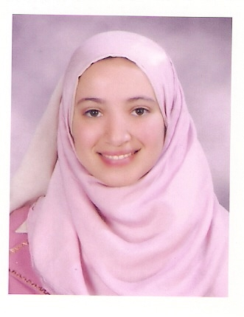
Name: AL-shimaa Mohamed Raaft
Age: 31
Residence: Cairo – Egypt
Contact: , 01026893667 ; shmpo21@yahoo.com

Education: -
Bachelor of medicine and surgery Cairo University –
Kasr al-ainy hospital of Egypt . (November 2007) with excellent degree with honor .

Post graduate study:-
- Master of parasitology from Cairo University
Kasr al-ainy hospital of Egypt with excellent degree.
With thesis titled parasitological screening of Cyclospora and
Isospora in patients with cancer.
- Medical doctoral degree (M.D) in parasitology exam will be held in November 2016 next month if my god want.
- With thesis titled
Assessment of IgG Avidity and IgA by ELISA Test with Reference to Indirect Haemaglutination Test for The Diagnosis of Active Toxoplasmosis During Pregnancy in Egypt

- First degree of dermatology diploma with very good degree 82% and second exam will be held in May 2017 if my good want ISA
Training:-
- One year as house officer training kasr alainy hospital.
Details of this year:
2 months emergency medicine .
3 months general surgery .
3 months general medicine.
2 months pediatric medicine.
2 months gyna and obstetric.
- Six month resident doctor of pediatric in pediatric ICU unit
in 6 October hospital Of health insurance.
- Three months as microbiologist in Theodor Bilharz institute.
- 4 years in parasitology department in kasr al-ainy hospital cairo university as demonstrator and as a doctor in practical parasitological unit in the department (DRUP).
- 2 years in parasitology department as assistant lecturer and as a doctor in practical parasitological unit in the department (DRUP).
- 2years and 2months as laboratory unit doctor in ALMOKHTABER lab under supervision of DR.AZZA ALADAWY.

Courses:-
- Course of immediate life support from LRC (learning resource center) council in Al-Kasr Alainy hospital Cairo University.

- Course of medical ethics and communication skills from Al-Kasr Alainy hospital Cairo University.

- Course of family medicine with excellent degree from Cairo University.

- Course of emergency medicine with excellent degree.

- Course of surgical and obstetric from LRC council in Al-Kasr Alainy hospital Cairo University.

- General course of British English 8 levels.

- I C D L with excellent degree.

- TOFEL test in the faculty of art of Ain Shanms University with score 550 at 2/6/2013.

- Molecular medical parasitology course (DNA extraction –PCR-Gel electrophoresis-Bio Informatics ) workshop in DRUP (diagnostic and research unit of parasitology) parasitology department–Kasr Alainy Hospital –Cairo university.

- Bright field microscope, handling calibration and measurement course in parasitology department–Kasr Alainy Hospital –Cairo University.

- Bio- statistical methods workshop in parasitology department–Kasr Alainy Hospital –Cairo university.

- Research methodology course in MEDC (medical development center) in Kasr Alainy Hospital –Cairo university.

- Research team management workshop in FLDC (Faculty and leadership department center) of Cairo university.

- The credit hour system workshop FLDC (Faculty and leadership department center) of Cairo university.

- Use of technology in teaching workshop FLDC (Faculty and leadership department center) of Cairo University with international license.

- Participation in organization of faecal examination for successful diagnosis of parasitic stages workshop in DRUP (diagnostic and research unit of parasitology) parasitology department–Kasr Alainy Hospital –Cairo university.

- Participation in organization copro –DNA extraction from stool samples workshop in DRUP (diagnostic and research unit of parasitology) parasitology department–Kasr Alainy Hospital –Cairo university .

- Participation in organization molecular techniques (DNA extraction-PCR- Gel electrophoresis) on blood samples work shop in DRUP (diagnostic and research unit of parasitology) parasitology department–Kasr Alainy Hospital –Cairo university.

- Quality control measures in FLDC (Faculty and leadership department center) of Cairo University with international license.
- Stool and urine analysis course from department of parasitology Cairo University.
- University code of Ethics in FLDC (Faculty and leadership department center) of Cairo University with international license.
- International publication of scientific research inFLDC (Faculty and leadership department center) of Cairo University with international license.

Languages:
Arabic: Mother Tongue
English: Excellent (Written & Spoken) (TOEFL score: 550 at 2/6/2013).
Computer skills: -
- Microsoft Office (windows-excel-word-power point- access –IT-internet).
- ICDL license.

