CORRICULUM VITAE
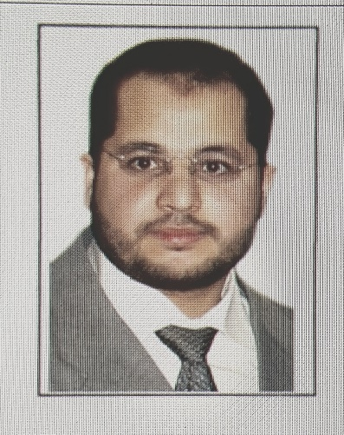Personal Information:
Name : Mohamed Hamed Ahmed Abouelfadl
Date of Birth : June , 29th , 1977
Place of Birth: Helwan , Cairo , Egypt.
Marital Status: Married, with 2 children 10 and 8.
Military Status: Finished the obligatory year in the army (from 10 /2003 to
12/2004) and finished Reserve recruiting period 01/12/2013.
Nationality : Egyptian
Address : 47S area B new Fostat city, Masr Alqadimah , Cairo , Egypt
Telephone : +2 01008433793
+2 0111 9905599
E-mail : Mohamed.abouelfadl@kasralainy.edu.eg
apoalfadl@gmail.com
Summary of Qualifications:
M.B.B.ch. Cairo University 2001.
Master degree of general surgery. Cairo University 2007.
Master degree of mini invasive surgery and new technologies, Scuola Superiore di Catania, ITALY 2011.
MD general surgery, Cairo University 2014.
Work Experience:
Current Job:
Employer: pediatric surgery department,
specialized pediatric hospital, Cairo University Hospitals.
Job Title: Lecturer.
Professional Clinical Experience:
Started my professional career in the department of general surgery from 23/4/2004
then in the specialized Pediatric Hospital of Cairo University where I joined the pediatric surgical department where I worked from till 15/9/2006.
During which I joined the neonatal surgical ICU where I was the only surgical
resident from 1/5/2005 to 1/12/205.
Conducted a thesis on a new approach for management of cases of I.H.P.S infantile
hypertrophic pyloric stenosis by traumatizing the muscle throw a small supra
umbilical incisions instead of the traditional Ramstad’s pyloromyotomy.
Afterwards, joined the trauma unit in The Emergency Hospital one of Cairo university hospitals for 6months as senior house officer of accident and traumatology in the traumatology unit in Cairo University hospital.
Later on, I travelled to Saudi Arabia for one year to work as a registrar of pediatric
surgery in King Fahd armed forces hospital in Jeddah.
Since July 2008 working as assistant lecturer of general and pediatric surgery
Cairo University Hospitals.
In 2010 travelled to Italy to have a year training in Catania, Sicily, Italy in Scuola
Superior di Catania and had a master’s degree in mini invasive surgery and new
technologies with training in the university hospital and had rotations in Milan,
Napoli, Modena, and Florence.
During that year I had a week training program in Paris, France with animal lab hands on training.
From 2012 till now I have been working for the Cairo University hospitals as an
assistant lecturer of pediatric surgery and now a lecturer of pediatric surgery and
from 03/2013till 09/2013 I was working as a specialist in the casualty department.
worked as Senior Registrar pediatric surgery in ROYAL COMMISION MEDICAL CENTER from December 2014 till may 2016 and transferred to king Abdulaziz University Hospital in Jeddah and started there may 26th , and finished my contact in May 20th 2017, SINCE THEN I returned to my original job as lecturer and pediatric surgery consultant in Abulreesh specialized pediatric hospital, Cairo university hospitals.

