Curriculum Vitae 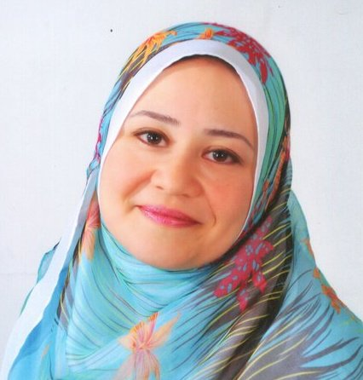

Personal Data

Full name: Abeer Ahmed Saba
Gender: Female
Birth date: 22.04.1973
Nationality: Egyptian.
Current job: Lecturer, Endodontic Department, Faculty of Dentistry, Cairo University.
Marital state: Married.
Address: 15 El Hassan St., Mohandeseen, Giza.
Phone number: home: 002-33352401 mobile: 01001192266
Email address: abeer.saba@dentistry.cu.edu.eg

Under Graduate Education

- High School Degree:
- La Rose de liseux School (1991).
- University Degree:
-Bachelor of Dentistry, Cairo University (May 1996).
-Grade: Very Good with Honors.

Post Graduate Education

-Master degree in Restorative Dentistry (Endodontics) - Cairo University (August 2004).
-Doctor Degree of Dental Science in Endodontics - Cairo University (February 2009).

Working experience and Positions Held

-Lecturer of Endodontics, Endodontic Dept., Faculty of Dentistry, Cairo University, from March 2009 -currently.
-Lecturer of Endodontics, Endodontic Dept., MIU University, 2011-2013 (part time).
-Assistant Lecturer of Endodontics, Endodontic Dept., Faculty of Dentistry, Cairo University, from 2004 – 2009.
-Demonstrator of Endodontics, Endodontic Dept., Faculty of Dentistry, Cairo University, from 2003 – 2004.
-Resident of Endodontics, Endodontic Dept., Faculty of Dentistry, Cairo University, from 1998 – 2002.
-Dentist at Egyptian Ministry of Health, from 1997-1998.
-Internship training for 12 months At Faculty of Dentistry, Cairo University and Ain-Shams University from 01.11.1996 to 31.10.1997.

Conferences and Workshops Attended

- International Conference of Oral and Maxillofacial Surgery (27-29 Sept 2000).
- Continuing Education in Endodontics, Egyptian association of endodontists (2002).
- 11th International Dental Congress, Egyptian Dental Association (16-19 Dec 2003).
- 12th International Dental Congress, Egyptian Dental Association (29Nov- 2 Dec 2005).
- Clinical Application of the Mineral Trioxide Aggregate, Egyptian Society of Endodontics (12 Dec 2006).
- 13th International Dental Congress, Egyptian Dental Association (20- 23 Nov 2007).
- 14th International Dental Congress, Egyptian Dental Association (11- 13 Nov 2009).
- 2nd International Dental Congress, Faculty of Oral and Dental Medicine Cairo University (24-26 March 2010).
- 15th International Dental Congress, Egyptian Dental Association (26-28 Oct 2011).
- 16th International Dental Congress, Egyptian Dental Association (5-8 Nov 2013).
- 3rd International Dental Congress, Faculty of Oral and Dental Medicine Cairo University (22-25 Jan 2013).

Scientific activities

-Co-supervisor of 12 Masters Degree Thesis, Endodontic Dept., Faculty of Dentistry, Cairo University.

Publications

- Push out Bond Strength of Glass Ionomer-Impregnated Gutta Percha/Glass Ionomer Sealer System to Root Canal Dentin Conditioned with Different Endodontic Irrigants. Egyptian Dental Journal, vol. 57, 3: 2351-2359
- The Life Span of Different Nickel Titanium Rotary Instruments in either Rotary or Reciprocating Motion Using Single File Root Canal Preparation Technique. Egyptian Dental Journal, vol. 58, 2: 1877-1885
- The Combined Effect of 980 nm Laser Diode and Different Irrigants on the Apical Microleakage and Adaptation of Root Canal Filling Materials. Egyptian Dental Journal, vol. 60, 3:3097-3105
- The Effect of Different Concentrations of the Proton Pump Inhibitor Omeprazole Mixed with Sodium Hypochlorite on Enterococcus faecalis: An in Vitro Study. Egyptian Dental Journal, vol. 60, 4:4297-4303
- An Ex-Vivo Quantitative Analysis of the Effect of Canal Instrumentation with Revo-S and ProTaper Next Using Cone Beam Computed Tomography. Egyptian Dental Journal, vol. 61, 1: 279-286
- Post-Treatment Radiographic and Clinical Evaluation of Matched-Taper Single-Cone Versus Warm Vertical Compaction Technique: A One-Year Follow up Study. Egyptian Dental Journal, vol. 61,1:765-770
- Effect of Different Root Canal Irrigants on the Push-Out Bond Strength of Two Rapidly Setting Calcium Silicate-Based Cements: MM-MTA and Biodentine. An In Vitro Study. Accepted for publication, Egyptian Dental Journal vol. 61, 2.

Skills
-Computer Skills (Word, Power Point, Excel, Internet).
-Languages: Excellent command of Arabic and English.

