Angular Distributions of Target Fragments Emitted in 14.6 A GeV
Silicon-Emulsion Interactions

A. Abdelsalam¹, M.S. El–Nagdy², A.M. Abdalla³, A. Saber³

1-Mohamed EL- Nadi-High Energy Lab, Physics Department, Faculty of science, Cairo university, Giza, Egypt. Abdallaham@hotmail.com
2- Physics Department, Faculty of science, Helwan University, Helwan, Egypt. Physicshelwan@yahoo.com
3- Mathematics and Physics Engineering Department, Faculty of Engineering in Shoubra ,Banha University, Cairo, Egypt.
a_abdalla65@hotmail.com and nasser.s2009@yahoo.com

Corresponding author: M.S. El–Nagdy (e. mail: Physicshelwan@yahoo.com)

Abstract

Many results obtained from studying the angular distributions of heavy fragments emitted from interaction of silicon nucleus with composite target nuclei of emulsion at collision energy 14.6 A GeV per nucleon. The angular distributions of grey and black secondary charged produced fragments are well described through statistical model. The average emission angle is ${64}^{°}$ for grey particles and ${82}^{°}$ for black particles that are nearly constant for different projectiles in range of collision energy 2.2 to 14.6 A GeV. The predicted rational velocity by statistical model$χ_{o}$ which describe the system responsible for production of secondary particle is nearly equal to 0.5 for grey particles and tends to be ~ 0.13 for black particles. The velocity of the emitting system described by parameter β//, where the emitting system for grey particles is fast with typical longitudinal velocities β//^{g} ~ 0.13-0.20 while it slow for emission black particle in the range β//^{b} ~ 0.008-0.019. The temperatures of the system responsible for emission of secondary slow fragments are found to be 58 and 6 MeV for fast grey and slow heavy fragments respectively. The angular distributions of slow fragments, grey and black particles show clear dependence on size of target nucleus. Most probable emission angles are in forward direction for interactions with light nuclei while it becomes symmetry around the middle angle for interactions with heavy nuclei. The emission system of these particles becomes slower and low temperature with increasing mass number of the interacting target nucleus.

PACS. 25.75.-q Relativistic heavy-ion collisions
Key words: slow fragments; angular distribution; forward and backward emission angles
- Introduction
Heavy ion collisions, with energy above few GeV per nucleon, are suitable conditions for investigation and studying the fine properties of nuclear matter. These collisions give the possibility for formation new states of compression phase of nuclear material with high temperature and density and possible signals for phase transitions with the so-called quark gluon plasma [1]. Much works have been performed both experimentally and theoretically for such investigations because it is more complicated due to the possible formation of new states of non-thermal equilibrium. Searching for unusual signals from formation, other intermediate nuclear states and their properties consider as very important tool to studying the new phases of the nuclear materials. These new states are produce during interactions between nucleons of the interacting nuclei with sufficient collision energies. Its physical properties play the major role and control the characteristics of secondary particles. Studying behavior of the interactions helps to get some important information about the dynamics of the collisions. In experiment, it impossible to measure all parameters that its describe the kinematic of the interactions but it can calculated from theoretical models which assumed upon different assumptions. One of the experimental parameters that are used to describe the nucleus-nucleus collisions is the angular distributions of fission fragments [2]. These parameters are an important probe and it can describe the possible mechanisms of fragmentation for both projectile, target nuclei, and investigate the particular flow of the observables and production secondary particles. In addition, it indicates to special structure about the formation and decay of some intermediate stages of interacting nuclei. The main aim of this work is studying experimental behavior of the angular distributions of slow and heavy fission fragments produced from interactions of silicon ions with composite target of emulsion nuclei at energy 14.6 GeV per nucleon. Experimental measurements have shown that the angular distributions of secondary fragments are sensitive to entrance channel parameters as well as the statistical aspects of intermediate system as it evolves in time. The obtained data will investigated in terms of the prediction of the statistical model [3,4] to describe the mechanism responsible for secondary particles production.
2. Statistical model
Statistical model defines a mathematical relationship between collections of variables, each variable being a vector of readings of a specific trait on the samples in an experiment. It explains in what way a variable depends on other variables in the study. Statistical model gives mathematical formulation, which embodies a set of assumptions concerning the generation of some sample data. This formulation correlates some of expected and other random variables. The assumptions embodied by statistical model generate a set of probability distributions. Some of which may be adequate to the experiment results than other models. The distribution of emitted secondary particles as a function of the emission angle θ, which are measured from direction of incident projectile, is one of important experimental parameter that describe the temperature and mechanical mechanism responsible for particle emission. To study this mechanism we will use statistical model for Maxwell distribution [3] for secondary emitted particle and their multiplicities according to their momentum as (let c=1)
$\frac{d^{2}N}{dP dμ} ∝ P^{2} exp\left\{-\frac{\left(P^{2}-2M\overline{β_{∥}} P_{μ} \right)}{P_{o}^{2}}\right\}$ (1)
where $β_{∥}$, is the longitudinal velocity of the particle-emitting system. $μ=\cos{θ}$, where $θ$ is the laboratory angle between the momentum of the fragment of mass M and the momentum of the initial projectile, and $P_{o}=\sqrt{2ME_{o}}$ , where $E_{o}$ is the characteristic energy per particle in the hypothetical moving system. Now we examine how Eq. (1) would be modified when it is expressed in terms of range R and $μ$, where the two quantities measured in experiment. Good approximation, the R and relation for emulsion is given by the power-low expression [3]
$β=k{\left(\frac{R Z^{2}}{A}\right)}^{n}$ (2)
where k = 0.174, n = 0.29, R is in mm, and Z and A are the atomic and mass numbers of the fragment, respectively. In terms of , Eq. (1) becomes
$\frac{d^{2}N}{dβ dμ} ∝β^{2} exp\left\{-\frac{\left(β^{2}-2\overline{β_{∥}} β_{μ} \right)}{{\overline{β}}_{°}^{2}}\right\}$ (3)

where ${\overline{β}}_{o}=\sqrt{2ME_{o}}$
If this distribution transformed to a distribution of particle range R, the distribution in R- space becomes
$\frac{d^{2}N}{dR dμ} ∝{\left(\frac{Z^{2}}{A}\right)}^{3n} R^{3n-1} exp\left\{-\frac{\left(k^{2}R^{2n}-2 β_{∥} k R^{n}μ \right)}{ β_{°}^{2}}\right\}$ (4)
where
$β_{∥}=\overline{β_{∥} } {\left(\frac{A}{Z^{2}}\right)}^{n}$ (5a)

and $β_{o}=\overline{β_{o} } {\left(\frac{A}{Z^{2}}\right)}^{n}$ (5b)

It follows that the parameter $χ_{∘ }$denoted as

$χ_{o }=\frac{β_{∥}}{β_{o}}=\frac{\overline{β_{∥} }}{\overline{β_{o} }}$ (6)

which is the ratio of the longitudinal velocity of the center of mass, , to the characteristic spectral velocity $β_{o}$, of the fragmenting system, is common to both the velocity and range spectra, and is independent of (A, Z). When the angular distributions are measured without regard to fragment velocity, becomes a function of the single fitting parameter$χ_{∘ }=β_{∥}/β_{o}$ only. In this case, the ratio of the number of fragments in forward to backward hemispheres, F/B is given by
$\frac{F}{B}=\frac{1+erfχ_{o}}{1-erfχ_{o}}$ (7)
To first order in $χ_{o}$, and F/B can be expressed as
$$\frac{dN}{dμ}≈\exp\left(\frac{4}{\sqrt{π}} χ_{o }μ\right) (8a)$$
$$\frac{F}{B}≈\exp\left(\frac{4}{\sqrt{π}} χ_{o }\right) (8b)$$Hence
$$\frac{dN}{dμ}≈{\left(\frac{F}{B}\right)}^{μ} (8c)$$
$\frac{dN}{dθ}≈sinθ{\left(\frac{F}{B}\right)}^{cosθ} (8d)$
The values of F/B obtained in experiment and equation (8a) was a good approximation of the exact expression dN/d.

3. Experimental Details
3.1 Experimental set up
In the present work, stacks of FUJI type of nuclear emulsion was exposed to the 14.6A GeV ²⁸Si beam at Brookhaven National Laboratory (BNL) Alternating Gradient Synchrotron (AGS). Each emulsion pellicle of the stack has 600 μm thickness and 20×10 cm² dimensions. The emulsion pellicles was doubly scanned along the tracks, fast in the forward direction and slowly in the backward one. The scanning of the emulsion pellicles was carried out using a 850056 STEINDORFF microscope. It has a stage of 18 ×16 cm² with an opening of 7×2.5 cm², stage adjustment in the x-direction is possible over a total length of 7.8 cm with a reading accuracy of the order 0.1mm. The total scanned length 121.8 m and 962 inelastic interactions were detected. The experimental technique, method of measurements and primary results of the experiment are explained in details in refs. [5-7].
When charged particle is passing through the photographic nuclear emulsion, it will slow down via losing its kinetic energy due to its inelastic interactions with the nuclear emulsion atoms along its path. The charged particle loses its kinetic energy via the ionizations of the grains of silver halides and via multiple elastic and inelastic scattering, which leading to trails of ionized silver halides along its path. The grain density defined as the number of developed grains of silver halides per unit path length of the particle’s track. It is denoted by (g) in a track corresponding to a particular value of specific ionization of such particle, so obviously it depends on some factors such as the degree of the development of the nuclear emulsion, the velocity and the charge of the ionizing particle. In order to obtain high accurate results, determine the normalized grain density g* where, $g^{*}=g/g_{o}$. The value $g$ , is the observed grain density per 100 μm for the emitted secondary particles after performing the dip angle correction. The magnitude $g_{o}$ is the grain density per 100 μm of the energy relativistic track of minimum ionization i.e. singly charged particle or electron. Both values of $g$ , and $g_{o}$ are counted in the same plateau region and at the same depth in the nuclear emulsion. The tracks of the secondary charged particles are produced which are classified into three types according to the normalized grain density${ g}^{*}$. The secondary charged particles classified according the grain densities into the categories as follow
- The Shower Tracks are characterized by the value of the normalized grain density ($g^{*}$ ≤ 1.4) and very high value of the velocity (β = v/c ≥ 0.7). Most of the shower particles are mesons with energy (E > 50MeV) contaminated with small fraction of fast protons with energy (E > 400MeV), charged K-mesons, antiprotons, and hyperons. The shower particles multiplicity denoted by (n_{s}), which its value gives good estimates of the number of the charged π-mesons produced in the interaction.
- The grey tracks are characterized by the value of the normalized grain density (1.4 < $g^{*}$≤ 10), the value of the velocity (0.3 < β < 0.7), where most of them are recoil protons having range in the nuclear emulsion (L > 3000 μm), which correspond to proton energies in the range from 26 MeV up to 400 MeV. Some of the grey tracks may be due to emitted deuterons, tritons, helium nuclei and nearly about (5%) due to slow π-mesons. The grey tracks multiplicity denoted by (N_{g}).
- The black tracks are characterized by the value of the normalized grain density $\left(g^{*}≥10\right)$, the value of the velocity (β ≤ 0.3), where most of them are due to protons having “Range” in the nuclear emulsion (L ≤ 3000), which correspond to proton energies (E < 26 MeV). The black tracks may be also due to deuterons, α-particles, and heavy fragments. The black tracks multiplicity denoted by (N_{b}). The grey tracks and the black tracks known as tracks of the heavily ionizing particles with the value of the velocity (β < 0.7). The heavily ionizing particles multiplicity is denoted by (N_{h}), where.
In this experiment, the target is composite nucleus. The inelastic interactions are classified into three groups, first is the interaction with hydrogen nucleus, H. Second are the interactions with light emulsion component carbon, nitrogen, and oxygen, CNO. The third is the interactions with heavy emulsion components silver and bromine AgBr. The separation of the interactions is based on the multiplicity of the second heavily ionizing charged particles N_{h}. Experimental tools for separation of interactions is explained in details in Ref.[8,9]. Interactions of N_{h}≤1 are with hydrogen nuclei while with CNO are those of 2≤N_{h}≤7. Interactions with heavy target group AgBr are of N_{h}≥8 with small contaminated in range N_{h}≤7 to change the results for interactions with CNO group.
3.2. Angles Measurements
The following text explains the method of measuring the space angle $\left(θ\right)$ of secondary charged and slow fragments. Assuming that, the primary beam moving in the $\vec{ XO}$ direction interacts with a particle or a nucleus at the point (A) and produces the secondary particle track $\vec{ AB}$ as shown in fig. 1. The dip angle $\left(α\right)$ is defined as the angle between the secondary particle track $\vec{ AB}$ and its projection in the nuclear emulsion plane plane i.e.$\vec{ AC}$.
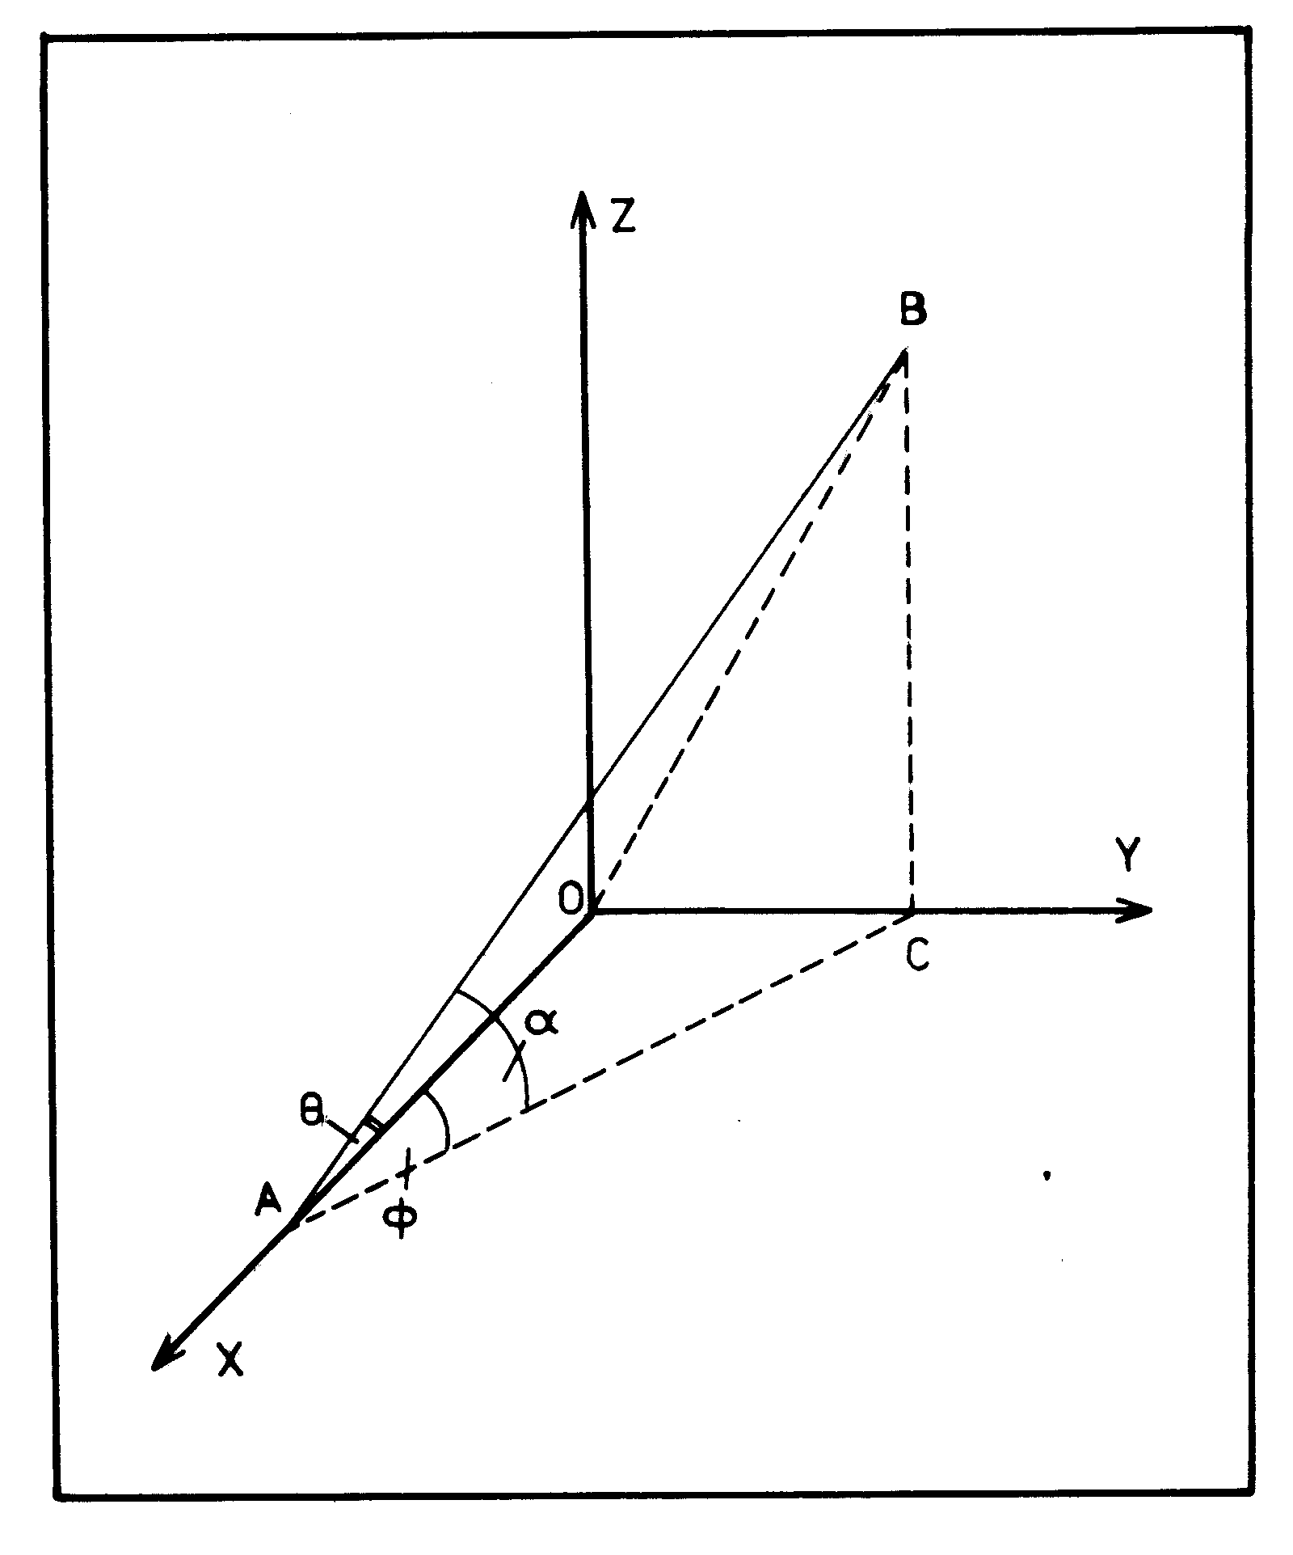
Fig.1 The geometrical representation for the beam and the Secondary Particle track

The projection angle $\left(φ\right)$ of the secondary particle track is defined as the angle included between the direction of the primary beam $\vec{ XO}$ and the projection of the secondary particle track $\vec{ AB}$ in the nuclear emulsion plane $\left(XOY\right)$ plane i.e. $\vec{ AC}$. The space angle $\left(θ\right)$ is defined as the angle included between the secondary particle track $\vec{ AB}$ and the direction of the primary beam$\vec{ XO}$.
$$\cos{φ}=\frac{OA}{AC} , \cos{α}=\frac{AC}{AB} and \cos{θ=}\frac{OA}{AB}$$
$\cos{θ=}\cos{φ} \cos{α}$ (9)
If the primary beam with the dip angle $\left(α\right)$, is adjusted to be parallel to the X-direction of the microscope, then the space angle $\left(θ\right)$ will have the form.
$\cos{θ}=\cos{φ }cos\left(α∓α_{o}\right)$ (10)
The experimental measurement of the stated angles are determined by the following tools
3.2.1 Measuring the projection angle
Measuring the projection angle $\left(φ\right)$ of the secondary particle track is performed through the following steps. When$\left(φ≥1^{°}\right)$.
- The nuclear emulsion plate should be placed and fixed on the metal stage of the microscope.
- The center of the interaction$\left(A\right)$ should be adjusted to be coincided with the center of the field of view.
- Using the rotatable metal stage of the microscope, the primary beam should be adjusted to be parallel to the X-direction of the microscope.
- The cross wire of the eyepiece is rotated to be coincided with each of the secondary particle track separately.
- Then taken the reading directly from the goniometry within accuracy of 0.02° using The KSM1 nuclear track measuring microscope, while using the Russian microscope type (MSU9) the accuracy become 0.1°.
When$\left(φ<1^{°}\right)$; the projection angle $\left(φ\right)$ of the secondary particle track is measured using the coordinate's method of the following steps.
- The metal stage of the microscope is moved a distance $\left(X\right)$ microns along the forward direction of the primary beam$\vec{ XO}$.
- Determination the $\left(Y\right)$ position at both of $\left(A\right)$ at the center of the interaction and at the moving distance$\left(X\right)$; so $\left(∆Y\right)$ is evaluated.
- Notice that the projection angle $\left(φ\right)$of the secondary particle track is ranging from 0° to ±180° and it is calculated by using the equation.
$φ= \tan^{-1}\left(\frac{∆Y}{X}\right)$ (11)
3.2.2 Measuring the space angle
Measuring the space angle $(θ)$ of the secondary particle track is performed through the following steps.
- The nuclear emulsion plate should place and fixed on the metal stage of the microscope.
- The center of the interaction (A) should be adjusted to be coincided with the center of the field of view.
- Using the rotatable metal stage of the microscope, the primary beam should be adjusted; so as to be parallel to the X-direction of the microscope.
- Determination the coordinates of each of (A) the center of the interaction, (B) a point in the secondary particle track i.e. $\vec{ AB}$ and $\vec{ AO}$.
$\vec{ AB}=x_{1}\hat{i}+ y_{1}\hat{j}+z_{1}\hat{k}$ (12)
$\vec{ AO}=x \hat{i}+ y \hat{j}+z\hat{ k}$ (13)
So, the space angle $(θ)$ of the secondary particle track is determined by using the equation (14)
$$\cos{θ}=\frac{\vec{ AB} \vec{ AO}}{\left|\vec{ AB}\right| ×\left|\vec{ AO}\right|}$$

$$=\frac{xx_{1}+yy_{1}+zz_{1}}{\left(\sqrt{\left(x^{2}+y^{2}+z^{2}\right)}\right)\left(\sqrt{x_{1}^{2}+y_{1}^{2}+z_{1}^{2}}\right)}$$ (14)
3.2.3 Measuring the dip angle
Measuring the dip angle $\left(α\right)$of the secondary particle track is performed through the following steps:
- The nuclear emulsion plate should be place and fixed on the metal stage of the microscope.
- The center of the interaction $(A)$ should be adjusted to be coincided with the center of the field of view then focused.
- Using the rotatable metal stage of the microscope, the primary beam should be adjusted to be parallel to the X-direction of the microscope then moving in the backward direction the rotatable metal stage of the microscope a distance 3000μm along the primary beam.
- Using the rotatable metal stage of the microscope, the secondary particle track; should be adjusted; so as to be parallel to the X-direction of the microscope then moving in the forward direction the rotatable metal stage of the microscope a distance 2000μm along the secondary particle track.
- Determination the $(Z)$ coordinate with respect to the glass of each of $(A)$ the center of the interaction i.e. $(Z_{star})$, $(B)$ a point in the secondary particle track” i.e. $(Z_{star})$ and at the distance 3000 μm i.e. $(Z_{star})$.
- By taken in our consideration that the primary beam has small deviation ${(α}_{o})$ from the nuclear emulsion plane (XOY) plane given by the equation
$α_{o}=\tan^{-1}\left\{K\left(\frac{Z_{star}-Z_{beam}}{X_{beam}}\right)\right\}$ (15)
where K is the shrinkage factor of emulsion
- The dip angle $(α)$ of the secondary particle track is given by the equation (16)
$α=\tan^{-1}\left\{K\left(\frac{Z_{track}-Z_{star}}{X_{track}}\right)\right\}$ (16)
8) The true dip angle $\left(α\right)$ of the secondary particle track is given by the equation (17)
$α=\left(α∓α_{°}\right)$ (17)
4. Experimental results
4.1. Angular distribution of grey particles
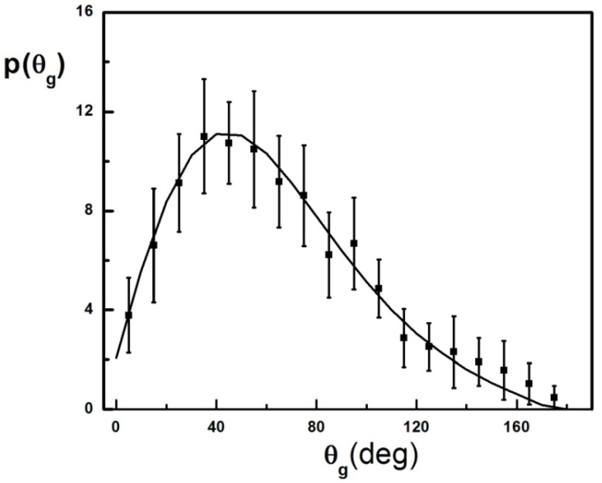
Fig.2 The angular distribution of grey particle emitted in ²⁸Si-Em interactions at 14.6A GeV. Smooth curve represents the corresponding prediction of the statistical model using from Eq. (8d).
Figure 2 shows the experimental angular distribution for grey particles emitted from ²⁸Si-Em at 14.6A GeV collisions. The smooth line represents the predictions for statistical model according to the Gaussian fitting shape from Eq. (8d) when applied for grey particles where
$$\frac{dN}{dθ_{g}}≈sinθ_{g} {\left(\frac{F}{B}\right)}_{g}^{cosθ_{g}} (18)$$
The predicted rational velocity$χ_{o}^{g}$, is calculated from statistical model by using the following equation,
$$χ_{o}^{g}=\frac{β_{∥_{g}}}{β_{∘}}=cos\left(<θ_{g}>\right) (19)$$It is noticed that within experimental errors the two distributions are in good agreement. The mean value of the emission angles $<θ_{g}>$ for grey particles is defined as the medium angle i.e. the angle at which half of the number of the specified particles is emitted. It is compared with the different projectiles in the range of energy 3.7-14.6 A GeV and magnitudes of the parameter $χ_{o}^{g}$ and $β_{∥g}$ are given in table 1. This caparison shows that this parameters are nearly constant and independent on projectile mass number which reflect the constancy of the mechanism which responsible for emission of this particles. Also from figure 2 it can be noticed that, the distribution shows a peaking shape with peak positioned nearly at $θ= <θ_{g}>$. The number of the backward emitted particles (i.e. θ > 90º) decreases with increasing θ. The distribution of such backward angles follows an exponential decay and studied before in ref. [10]. From table 1 and fig.2 it is noticed that, The constancy in the values of $<θ_{g}>$ ~ 64, independent of the variation of projectile mass number as well as incident energy. The rational velocity for the system of grey particle emission$χ_{o}^{g}$ is nearly equal 0.5 for different interactions studied here. The emitting system of the g-particles is fast and with typical longitudinal velocities β// ^{g} 0.13-0.20. The anisotropic ratio (F/B)_{g} is the ratio of the number of forward fragments of grey particles to that emitted in the backward for different projectiles are given in table 1. This ratio is appear constant and ranged between two and three. It proves that all predictions of statistical models for all given projectiles are similar and controlled by a fixed mechanism for grey particle productions.
Table 1 The average values of the emission angles of the grey particles
$<θ_{g}>$in different interactions at (3.7-14.6A GeV), in addition to the rational velocitiy of the system$χ_{o}^{g}$, ratio (F/B)_{g} and longitudinal velocity $β_{∥_{g}}$based on statistical model
Projectile | Energy  A GeV | $$<θ_{g}>$$ | $$χ_{o}^{g}$$ | (F/B)_{g} | $$β_{∥_{g}}$$ | Ref.
⁶Li+Em | 3.7 | 64.90 ± 2.20 | 0.33 | 2.12±0.13 | 0.11 | 11-13
¹²C+Em | 3.7 | 64.00 ± 1.90 | 0.52 | 3.51±0.20 | 0.18 | 14-20
²²Ne+Em | 3.3 | 63.70 ± 1.60 | 0.54 | 3.38±0.28 | 0.19 | 15-21
²⁸Si+Em | 3.7 | 63.30 ± 1.44 | 0.55 | 3.38±0.28 | 0.19 | 15-17,20,21
²⁸Si+Em | 14.6 | 64.76 ± 2.06 | 0.49 | 3.05±0.27 | 0.17 | Present work
²⁸Si+CNO | 14.6 | 62.44 ±5.18 | 0.46 | 2.84±0.24 | 0.16 | Present work
²⁸Si+AgBr | 14.6 | 65.56 ±3.51 | 0.41 | 2.54±0.25 | 0.14 | Present work
Now we will explain the effect of target size on the angular distribution of secondary charged and slow particles grey and black. In this experiment, target is compound nucleus and easy classified into three main groups of interactions. Experimentally, classification of these interactions is characterized by multiplicity of heavily ionizing secondary charged particle N_{h..} These particles are pure target fragments and are an experimental parameter, which describe the degree of overlapping of projectile and target nuclei. First group with multiplicity N_{h}≤1 is the interactions with hydrogen and are low statistics to exclude from this consideration. Second group is the interactions with light emulsion components CNO, where 2≤ N_{h} ≤7 and consider as gentle interactions. Third group is the interactions of ²⁸Si with heavy emulsion nuclei AgBr. It considers as hard interactions and characterize by N_{h} ≥8. Figure 3 shows the angular distributions of grey particles for interactions of ²⁸Si with CNO and AgBr nuclei at collision energy 14.6 A GeV. In this figure, the angular distribution for both target components are different where most of probable angles for gentle interactions are for angles in the forward hemisphere $(θ≤$90º) and minimum probability for angles in backward hemisphere. In hard interactions in forward hemisphere the probability gradually small increases and most values of probability is observed in the backward hemisphere and it uniformly distributed in wide range of angles to reach the backward directions ($θ$=180º). This is observed from the ratio (F/B)_{g} in table 1 where its value for gentle interactions 2.84±0.24 while it 2.54±0.25 for hard interactions. In addition, the average angle of emission for gentle interactions is 62.44º ±5.18 and it increases to 65.56º ±3.51 for hard interactions. The rational parameter $χ_{o}^{g}$ decreases with target mass number i.e. the system of emission of grey particles becomes slower of emission with target mass number. This could explain if we consider the increasing in the number of target nucleons increases the number of binary collisions. This become sufficient for projectile nucleons to lost most of momentum up to emitted recoil fragments in wide range of angles, and reach maximum angles opposite to original direction of incident projectile.

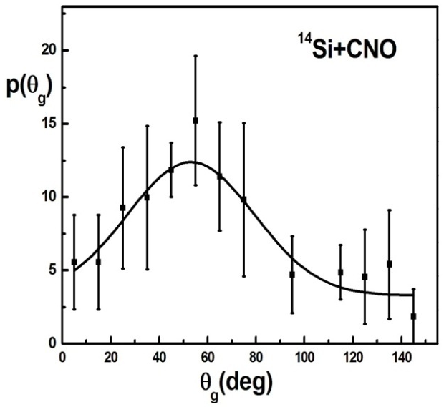 | 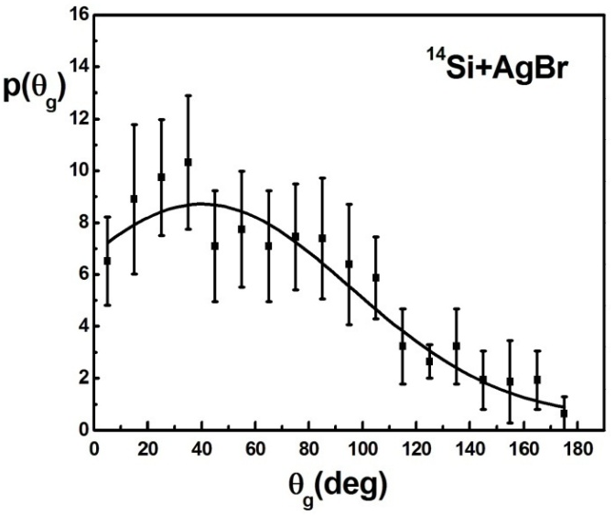
Fig.3 The angular distribution of grey particle emitted ²⁸Si interactions at 14.6A GeV with light emulsion component CNO and heavy component AgBr. Smooth curve represents the corresponding prediction of the statistical model using Gaussian-fitting shape.
4.2 Angular distribution of black particles
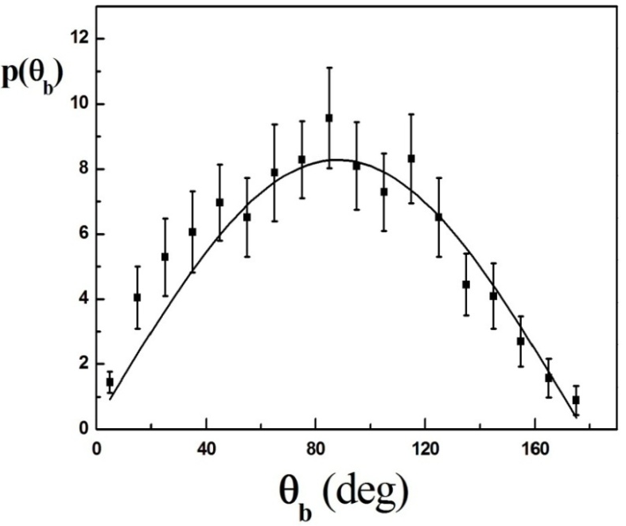
Fig.4 The angular distribution of black particle emitted ²⁸Si-Em interactions at 14.6A GeV. Smooth curve represents the corresponding prediction of the statistical model using Gaussian fitting shape from Eq. (8d).
Second, in this section we will study the angular distributions and properties of the collisions responsible for production of slow particles, which appear as black tracks in emulsion experiments. These particles play an important role to describe the mechanism of the interactions between projectile and target nuclei. It’s mainly target fragments and emitted during the last stage of interactions as an evaporated particle from residual target nucleus. It contains massive particles with minimum energy emitted in a wide range of angles, which are independent on direction of the incident projectile especially more heavy black fragments. The experimental data for angular distribution of the emitted black particle from ²⁸Si-Em interactions at energy 14.6 A GeV with the corresponding prediction of the statistical model are shown in fig. 4. The mean value for this distribution is compared with other projectiles and is given in table 2. It is noticed that the spectrum seems to be symmetric about the peak position, which is near from the mean value. The feature of this spectrum implies that, the emission of black particles, in forward and backward hemispheres tends to be symmetric in both directions, where the particle multiplicity increases in the vicinity region of .
Table 2 The average values of the emission angles of the black particles
$<θ_{b}>$in different interactions at (2.2 -14.6A GeV), in addition to the rational $χ_{o}^{b}$velocity of the system, the ratio (F/B)_{b} and longitudinal velocity $β_{∥_{b}}$ of black particle emission, on the basis of statistical model.
projectile | Energy  A GeV | $$<θ_{b}>$$ | $$χ_{o}^{b}$$ |  | (F/B)_{b} | $$β_{∥_{b}}$$ | Ref.
⁴He+Em | 3.7 | 83.00±3.80 |  | 0.13 | 1.33±0.07 | 0.014 | 14,22
⁶Li+Em | 3.7 | 82.20±2.60 |  | 0.12 | 1.29±0.06 | 0.013 | 19,23
⁷Li+Em | 2.2 | 81.30±2.30 |  | 0.17 | 1.48±0.07 | 0.018 | 19,23
¹²C+Em | 3.7 | 79.50±2.10 |  | 0.18 | 1.27±0.10 | 0.019 | 14
²⁸Si+Em | 3.7 | 83.30±1.18 |  | 0.17 | 1.59±0.07 | 0.018 | 15-17
²⁸Si+Em | 14.6 | 83.54±1.89 |  | 0.11 | 1.26±0.08 | 0.012 | Present work
²⁸Si+CNO | 14.6 | 79.98 ±3.70 |  | 0.17 | 1.48±0.08 | 0.019 | Present work
²⁸Si+AgBr | 14.6 | 84.96 ±2.18 |  | 0.09 | 1.22±0.07 | 0.010 | Present work
If equations (9) and (10) for statistical model are applied for black particles it gives the values of the rational velocity $χ_{o}^{b}$ and longitudinal velocity $β_{∥_{b}}$ and are given in table 2. The values of β_{o}^{b} ~ 0.115 (from ref.[4]). It can conclude that the constancy in the values of $<θ_{b}>\sim {83}^{°},$ independent of the variation of projectile mass number as well as incident energy. The predicted rational velocity $χ_{o}^{b}$ according to statistical model tends to be ~0.13 for the system, which is responsible for black particle emission. The ratio (F/B)_{b} for black particles is more concise for different projectiles in small range 1.2-1.6 describe a fixed mechanics of black particle production and different that for grey system. The emitting system of the b-particles is slow and has a typical longitudinal velocities β//^{b} lie in the range β//^{b}~ 0.008-0.019. The temperature of the emitting system of black particle can calculate using $T=1/2Mβ_{°}^{2}$ where M is the nucleon mass. It value is found to be for black particle is equal to 6 MeV per nucleon which is approximately equal to the binding energy per nucleon for in normal state of nucleus. The corresponding temperature for the system responsible for grey particle production is calculated by using the magnitude of β_{o}^{g} ~ 0.35 (ref.[4]) is found to be 58 MeV which is much sufficient for protons to make cascading of secondary interactions before emitted from hot size of interactions.
The interesting observations are the effect of target mass on the angular distributions of black particles. This effect for both two-target components is shown in figure 5. The studied experimental parameter is shown in table 2. It is clear that for gentle interactions the emission of evaporated black particles begins from angles 20º and most probabilities equal distributed to reach 90º and begins in fast decreasing with lower probability in backward directions. This means that the distribution is not homogenous about any specific angle. The corresponding distribution for hard interactions with AgBr nuclei shows a uniform distribution in all possible range of emission angles and there is a similarity of emission angles on forward and backward hemispheres of emission angles. The mean value of emission angles is about 85º, which reflect the symmetry of distribution in the middle angles of the range of emissions. This symmetry is deviated for CNO interactions. The ratio (F/B)_{b} and rational parameter $χ_{o}^{b}$ decreases from 1.48±0.08 and 0.17 in gentle interactions to 1.22±0.07 and 0.09 for hard interactions respectively. It proves that the system of emission black particles becomes slower and low temperature with increasing mass number of the interacting target nucleus.
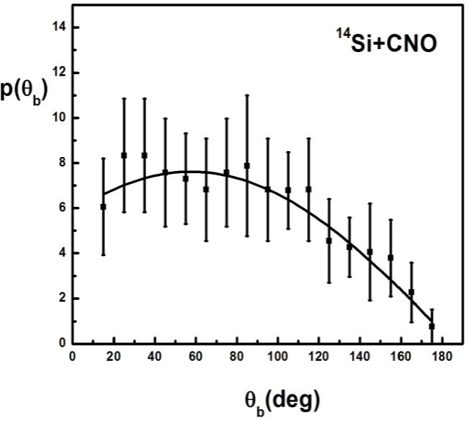 | 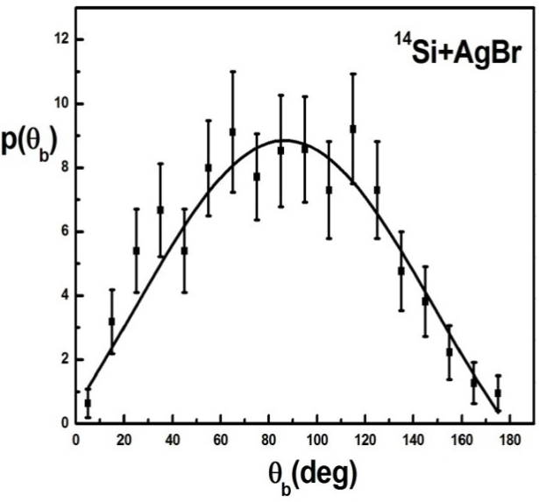
Fig.5 The angular distribution of black particle emitted ²⁸Si interactions at 14.6A GeV with light emulsion component CNO and heavy component AgBr. Smooth curve represents the corresponding prediction of the statistical model using Gaussian-fitting shape.

Conclusions
- The angular distribution of grey and black particles emitted from ²⁸Si-Em interactions at energy 14.6 A GeV are well described by statistical model
- The experimental parameters such as mean values of the emission angles of grey $<θ_{g}>\sim {64}^{°}$ and black $<θ_{b}>\sim {83}^{°}$ are nearly constant with the corresponding collisions with different projectiles within range of collision energy 2.2-14.6 A GeV.
- The predicted rational velocity $χ_{o }$ by statistical model which characterize the system responsible for secondary particle emissions is nearly equal 0.5 for grey particles and tends to be ~ 0.13 for black particles.
- The velocity of emitting system is describe by the parameter β//, where the emitting system for g-particles is fast and with typical longitudinal velocities β// ^{g} ~ 0.13-0.20 while it slow for emission of black particle in the range β// ^{b} ~ 0.008-0.019
- The anisotropic ratio (F/B) is found to be 2-3 for system responsible for grey particle productions while it is 1.2-1.6 for system of black particle production.
- The temperatures of the system responsible for emission of secondary slow fragments are found to be 58 MeV for grey particle productions while 6 MeV for black and slow heavy fragments.
- The angular distributions for both grey and black particles depend on the size of the target nucleus where most of emission angles for grey particles is mainly in forward angles for small target nuclei CNO, while it in symmetry distributions between forward and backward hemispheres for heavy target AgBr.
- The system responsible for grey and black particle productions becomes slower and low temperature with increasing target mass.
Acknowledgment
The authors would to thanks P.L. Jain for supplements of the irradiated emulsion plates
References
- S.K. Karn, R.S. Kaashal, and Y.K. Mathur, Z Phys. C, 72, 297 (1996). doi:10. 1007/s 002880050249
- A. Abdelsalam, M. Šumbera and S. Vokál, JINR, El–82–509, Dubna (1982).
- H.H. Hackmann, H.J. Crawford, D.E. Greiner, P.J. Lindstrom and W. Wilson Lamce, Phys. Rev. C17, 1651 (1978).
- A. Abdelsalam, Phys.Scr., 47,124 (1993).
- M. El-Nadi, M S El-Nagdy, N Ali-Mossa, A. Abdelsalam, A M Abdalla and A.A. Hamed, J.Phys. G:Nucl. Phys. 25, 1169-1178 (1999).
- M El-Nadi, et.al., The European Physical Journal A-Hadrons and Nuclei 10 (2), 177-181 (2001).
- M. El-Nadi, et.al., Journal of Physics G: Nuclear and Particle Physics 28 (6), 1251 (2002).

J.R. Florian et al; Report submitted to the meeting of Division of particles
and fields, Berely, California (1973).
- A. Abdelsalam, JINR Report (Dubna) El-81-623(1981).
- A. Abdelsalam, M. S. El-Nagdy, A. M. Abdalla and A. Saber, International Journal of Modern Physics E Vol. 24, No. 11, 1550084 (2015)
- M.I. Adamovich; et al. LUND Report LUIP 8906 (1989).
- M. El-Nadi, A. Abdelsalam, N. Ali-Moussa, Z. Abou-Moussa, S. Kamel, K. AbdelWaged, W. Osman and Badawy, Eur. Phys. J. A 3, 183 (1998).
- M. El-Nadi, A. Abdelsalam, N. Ali-Moussa, Z. Abou-Moussa, S. Kamel, Kh. AbdelWaged, W. Osman and B. M. Badawy, IL Nuovo Cimento A 111, 1243 (1998).
- A. Abdelsalam, Phys. Scr., 47, 124 (1993).
- M. El-Nadi, A. Abdelsalam and N. Ali-Moussa, Int. J. Mod. Phys. E. 3, 811 (1994).
- M. El-Nadi, A. Abdelsalam and N. Ali-Moussa, Radiat. Phys. Chem. 47, 681 (1996).
- M. El-Nadi, A. Abdelsalam and N. Ali-Moussa, IL Nuovo Cimento A 110, 1255 (1998).
- A. Abdelsalam, E. A. Shaat, N. Ali Mossa, Z. Abou-Moussa, O. M. Osman,
N. Rashed, W. Osman, B. M. Badawy and E. El-Falaky, J. Phys. G 28, 1375 (2002).
- LI. Hui-Ling, Z. Dong-Hai and LI. Jun-Sheng, Chin. J. Phys. C (HEP&NP) 33, 521(2009).
- A. Abdelsalam, B. M. Badawy and E. El-Falaky, Can. J. Phys. 85, 837 (2007).
- M.M.Sherif, Il Nuovo Cimento Vol. 109A, 1135 (1996).
- A. Abdelsalam, M. S. El-Nagdy, N. Rashed, B. M. Badawy and E. El-Falaky, J. Nucl.Radiat. Phys. 2, 49 (2007).

M. El-Nadi, A. Abdelsalam, N. Ali-Moussa, Z. Abou-Moussa, Kh. Abdel-Waged, W. Osman, and Badawy, IL Nuovo Cimento A111, 1243 (1998).

