Abdallah Mohamed Mostafa Nosair
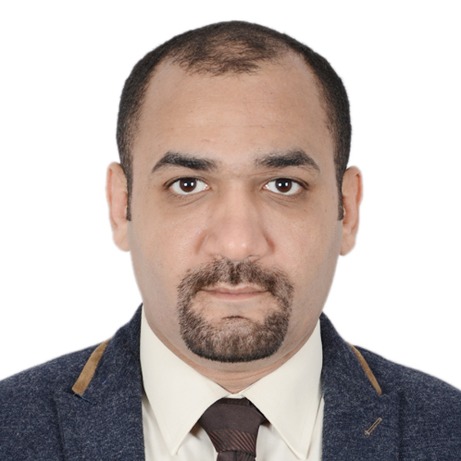
Lavida Elbostan compound- 6 october- Giza
0201221093933
E-mail: abdallah_nosair@live.com

Career Objective
Obtaining apropriate cardiothoracic surgery related job where I can demonstrate my technical and medical skills and contribute to the hospital progress.

Summary of Qualifications

- M.B.B.CH 2005
- House officer at cairo university hospitals 2006-2007
- Residency in cardiothoracic department at cairo university 2007-2010
- M.Sc of general surgery 6-2011
- MD degree in cardiothoracic surgery 11- 2013
- MRCS of England in general surgery 6-2015

Education

- Cairo university , Faculty of medicine (Kasr Al Aini) and Aboelresh children hospital
lecturer in cardio thoracic surgery department 1 1- 2013
- Cairo university , Faculty of medicine (Kasr Al Aini) 2012 2014
Assistant lecturer in cardiothoracic department
- Cairo university , Faculty of medicine (Kasr Al Aini) 2011  Master degree of general surgery (M.Sc of surgery) and was signed up  (very good ) | 2011
- The Royal college of surgons of England
Part 1-(Applied basic sciences) 2007
Part 2-(Clinical problem solving) 2009
Part 3 –(oral, viva and clinical examination) 2011-2015
- Cairo university , Faculty of medicine (Kasr Al Aini)
Resident physician at cardiothoracic department . 2007-2010
- Cairo university , Faculty of medicine (Kasr Al Aini)
Intern at cairo university hospital . 2006-2007
- Cairo university , Faculty of medicine (Kasr Al Aini)
Graduated and obtained M.B.B.CH and was signed up (Excellent) 2005

Employment Experience
- Consultant of CTS in : private hospials :Misr university , Alamal, Dream, alzeraeen, October university, Almoalmen, New fransawi teaching , Elmanil specialized, Elwady, alarabi hospitals monofia, Egypian cardiac center banisweif, police Alexandria hospital
- Head of cardiac surgery in Elwady Hospital October 2017-2019
- lecturer in cardio thoracic surgery department cairo university and aboelresh children hospital 2013-till now
- Assistant lecturer in cardiothoracic department cairo university 2012-2014
- Ministry of health- Zyton hospital 2011-2013
Registrar in the thoracic surgery department
- Dar elfoad hospital Registrar in the thoracic surgery department 2012
- Naser institute – ministry of public health 2011
Registrar in the thoracic surgery department
- New kasr Al Aini Educational hospital (El Fransawi hospital) 2010-2011
Registrar in the cardiothoracic surgery department
- 6 October university hospital
Registrar in the cardiothoracic surgery department 2010
- El maady military hospital 2009-2010
Resident physician at cardiothoracic department during the performing the military service

Related Skills

- Computer use skills is excellent and passed training course 10/2009
- Passed the TOEFL test at the center for foreign languages and translation -Cairo university. 9/2009
- Medical research and statistical course at cairo university 1/2009

References

Available upon request

Much obliged
ABDALLAH NOSAIR

