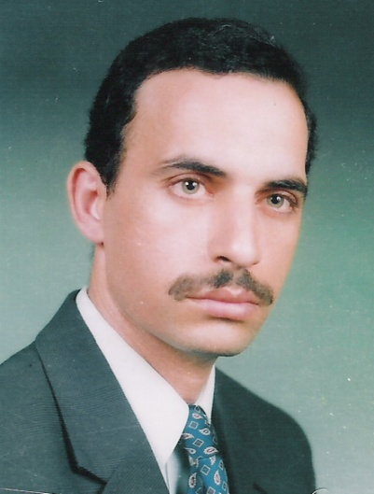
Professor Ashraf A. Abbas was born in Egypt in September 1968 and he is presently Professor of Organic Chemistry, Department of Chemistry, Faculty of Science, Cairo University, Giza, Egypt since 2009. He graduated from Cairo University in 1990. He received his M.Sc. and Ph.D. degrees in 1994 and 1997, respectively, from Cairo University. He spent Six months in the Fakultat fur Chemie, universitat of Konstanz (Germany) on a DAAD fellowship (1996) to finish his Ph.D. thesis and one year in Tokyo Institute of technology (TIT, Japan) as UNESCO fellow (postdoctoral fellowship) from Oct 2001 to Sept 2002. He received several research prizes in chemistry; 1) he was awarded the prize of Prof. Dr. Mohamed Abdel Salam in chemistry (2001) for young scientists provided by Academy of Scientific Research and Technology (Egypt). 2) he was awarded the Cairo university encouragement prize in Chemistry in 2004. 3) he was awarded the Third Word Academy of Science (TWAS) prize in chemistry for young scientists in 2004 provided by ICTP-Strada, Triesta-Italy, 4) he was awarded the State Award in Chemistry, Egypt 2005. He published many papers in the field of synthesis and applications of macrocycles and bis-heterocycles chemistry.

