Curriculum Vitae
Mustafa abdelsamie nafie
Address: alharam street, Giza Phone number: 01004165905
Contact e-mail:mostafa.abdelsamie@dentistry.cu.edu.eg
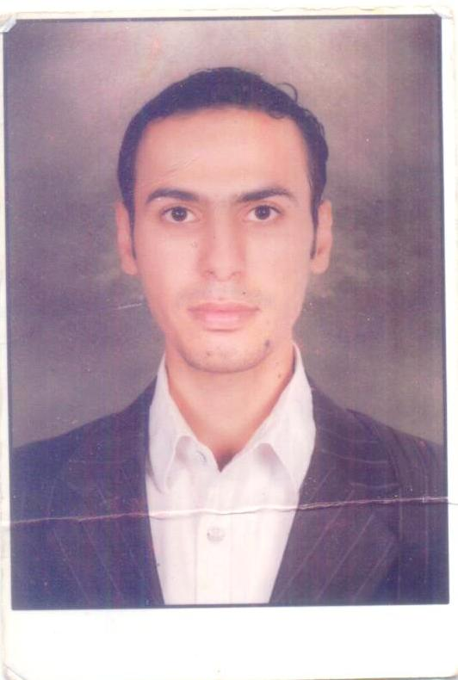
Career objective:
A position as Oral Medicine staff member where my teaching experience and technical skills would be useful in fostering the growth of the organization.

Occupational information:
Occupation: demonstrator of Oral Medicine.
Department: Oral Medicine and Periodontology department
Institution: Faculty of Oral and Dental Medicine, Cairo University

Educational information:
Educational degree: Excellent with degree of honors
Rank: 23rd among colleagues
Graduation year: 2011
Master thesis protocol: using topical q10 gel in oral recurrent aphthous ulcers

Responsibilities and achievements:
Teaching undergraduate students (in practical sessions)
Preparing Oral Medicine cases (diagnosis and treatment)
Working with interns in the diagnostic center, Faculty of Oral and Dental Medicine, Cairo University
Taking different types of biopsy for diagnostic reasons
Making seminars and case presentations
Attending dental conferences in Egypt
Screening for oral cancer

Honors:
Honoring from Faculty of Oral and Dental Medicine, Cairo University
Invitation from Kiel University, German for 3weeks

Skills:
Power point presentation skills
Technical and Teaching skills (medical education course)

Languages:
Arabic : Mother tongue
English: Perfect command of written and spoken.

